**NINGALA, LEIRAH MAE M.**

**GABRIEL, GRACIELLE ANNE D.**

**BSIT-NT 3301**

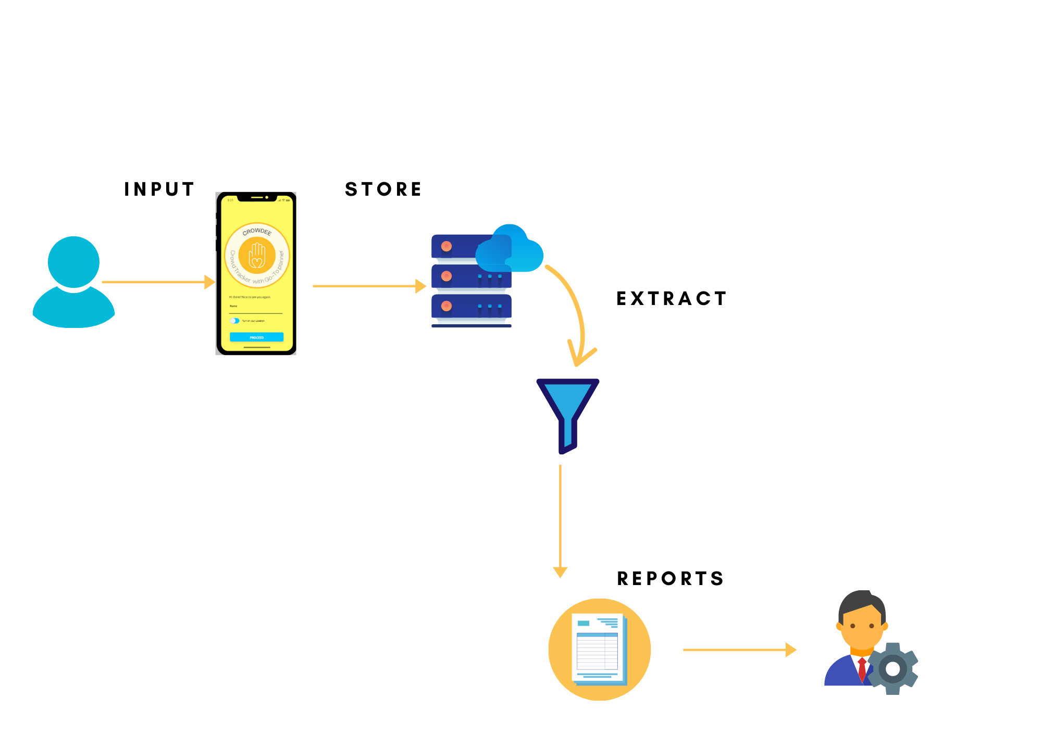**DATA INTEGRATION APPROACH OF CROWDEE: AN ONLINE ANDROID BASED ESTABLISHMENT CROWD TRACKING APPLICATION WITH GEO-FENCING AND GO-TO PLANNER**